Fire detection Fire Vs NoFire

Reading data

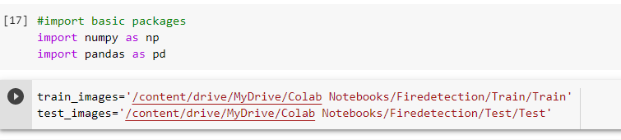

Defining the images in the folder and image size

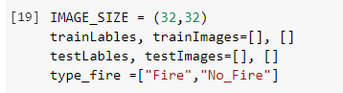

Train and Test Images

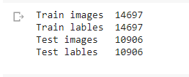

Building the Model

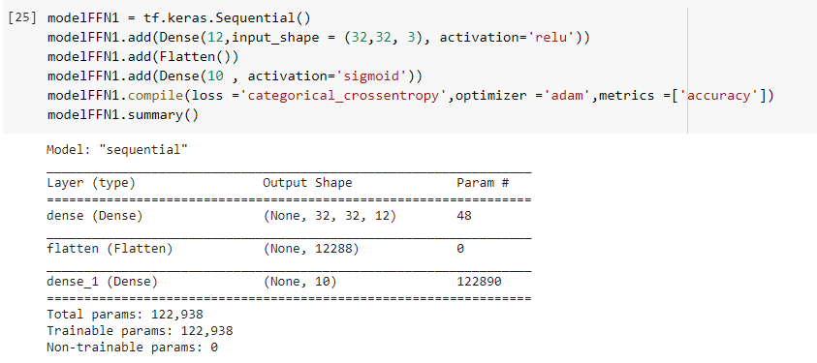

Evaluating the Model

Loss and Accuracy

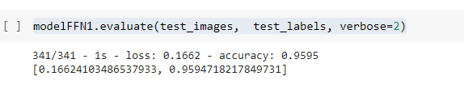

Train and Validation Accuracy

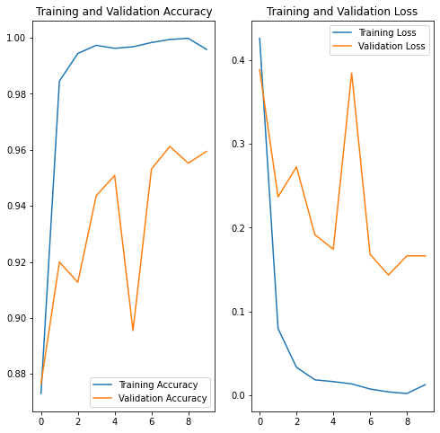

Confusion Matrix

